IT Ticket Analysis Report
Submitted by: Ashish Kumar
Platform: Newton School
Date: 05/11/2025

Section 1: Objective Questions -

Q1. What is the total no. of attributes present in the data?
Tickets Sheet -
Given Attributes - ID Ticket, Fecha, Employee ID, Agent ID, Request Category, Issue Type, Severity, Priority, Resolution Time, Satisfaction Rate.
Newly added attributes - Year, Month, Day, Month-Year, Agent Name, Total Category, SeverityNum, Correl, Age
IT Agents Sheet -
Given Attributes - Agent ID, Full Name, Email, Year of Birth, Month of Birth, Day of Birth.
Newly Added Attributes - EmailDomain, DOB, Age
Common attribute in both of the sheets is Agent ID but I add Age in both of the sheets for make better analysis.
Therefore the total number of attributes in both of the sheets are = 26

Q2. Which columns have inconsistent or missing values, and what is the count of such values?
There are no any missing values in both of the sheets.
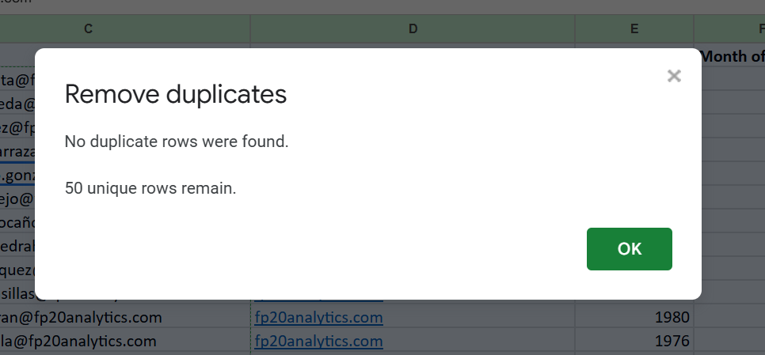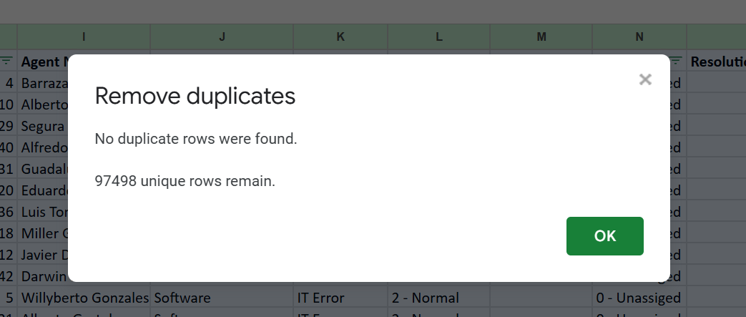
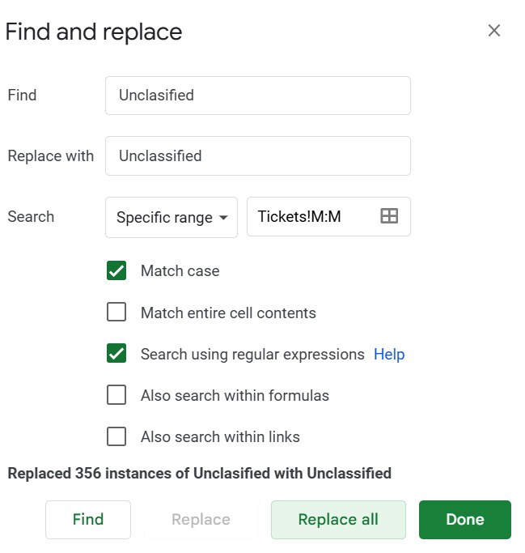
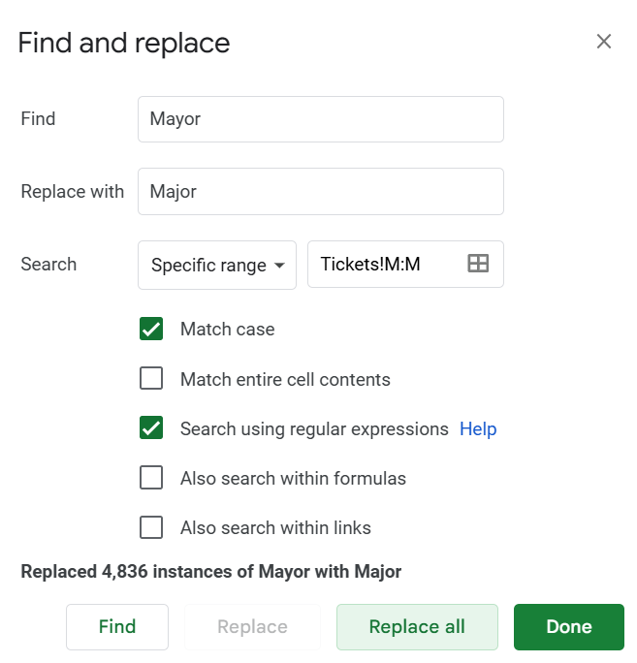
But there are two Inconsistent Values in Severity Column - Unclassified and Mayor. Which is replaced by using Find and Replace.

Q3. What is the average daily ticket volume over time?
The average daily ticket volume over time(Year-Month) - 1624.966667
Average daily ticket volume = Total number of tickets / Total number of days
To find the total number of tickets using pivot, Add the ticket Id to the values section as count of ticket id. = 97498
To find total number of days, we can use formula, =rows(unique(A:A)) = 1827
Applying formula,
Average daily ticket volume = Total number of tickets / Total number of days
= 97498 / 1827
= 53.36

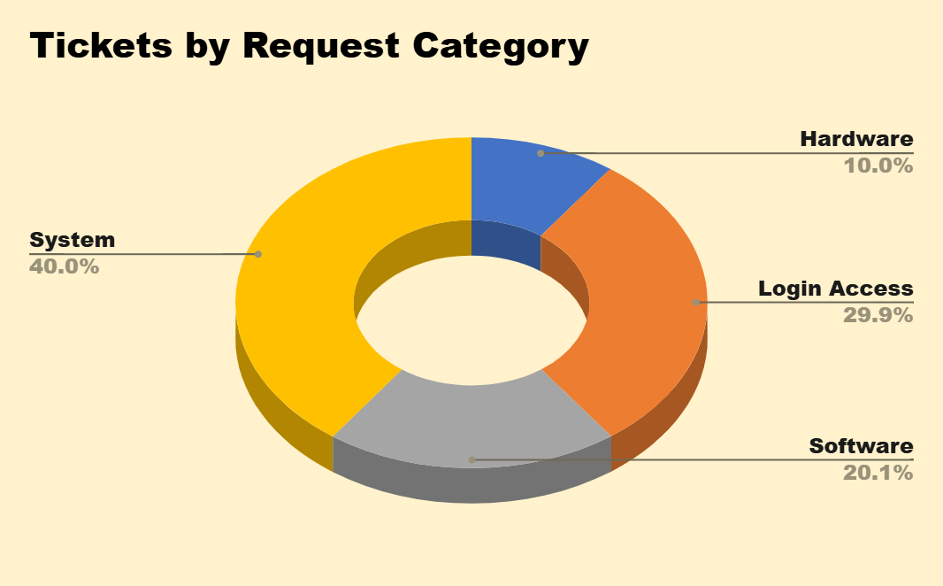
Q4. What is the distribution of ticket categories (e.g., Login Access, System, Software)?
- System: 39002 tickets (40.0%)
- Login Access: 29193 tickets (29.94%)
- Software: 19570 tickets (20.07%)
- Hardware: 9733 tickets (10.0%)

Q5. How many tickets has each agent handled?
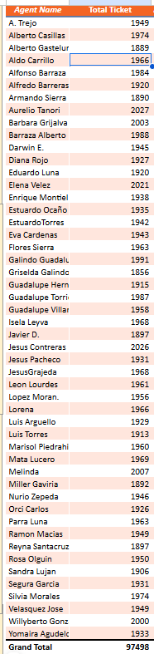

Q6. How can you extract the domain from the email addresses in the IT Agents sheet?
The domain to extract from email address is :- fp20analytics
We can use =MID(C2,FIND("@",C2)+1,FIND(".",C2,FIND("@",C2))-FIND("@",C2)-1) to extract this domain from email address column.

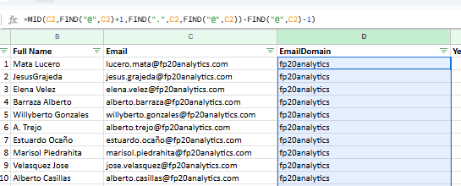

Q7. How can you find the full name of an agent given their Agent ID?
We can use =IFNA(VLOOKUP(H2,'IT Agents'!$A$1:$G$51,2,0),"Unkown") to find the full name of agents in Ticket Sheet.
Example: Agent ID 1 → Mata Lucero
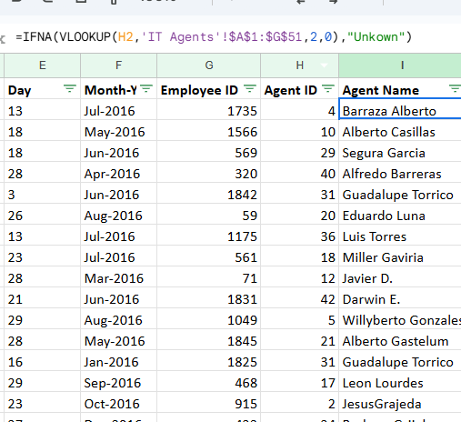

Q8. What is the count of each issue type (e.g., IT Error, IT Request)?
- IT Request: 73220 tickets (75.1%)

- IT Error: 24278 tickets (24.9%)

This is the Chart showing the ratio of tickets per Issue Type -
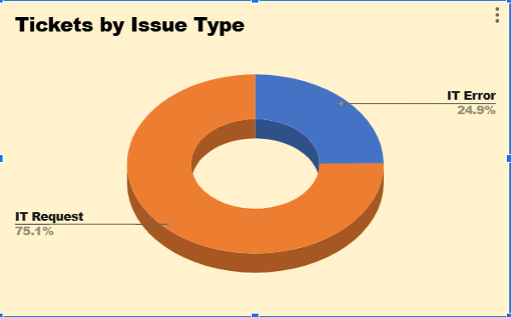

Q9. What is the daily average resolution time for tickets?

Overall average resolution time (across all tickets): 4.55 days


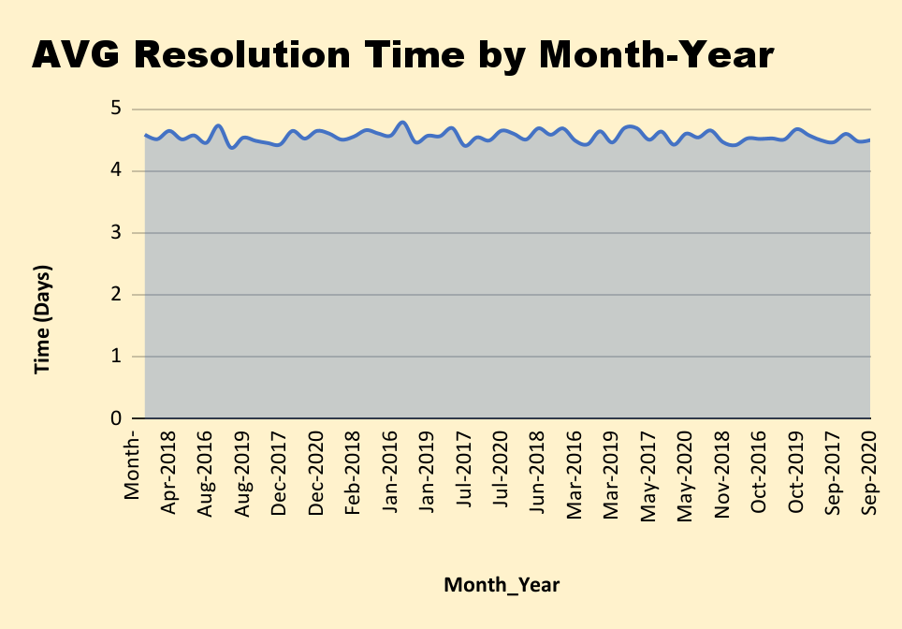

Q10. How has the volume of tickets changed over time?
Yearly ticket counts:
- 2016: 13051 tickets
- 2017: 14915 tickets
- 2018: 18954 tickets
- 2019: 21490 tickets
- 2020: 29088 tickets
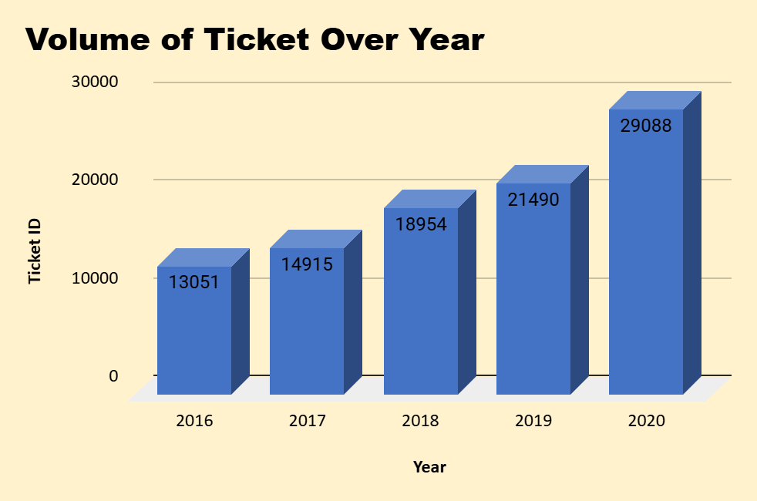
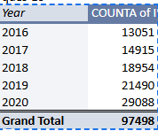

Q11. What is the average age of the IT agents?
Average age of IT agents is :- 40
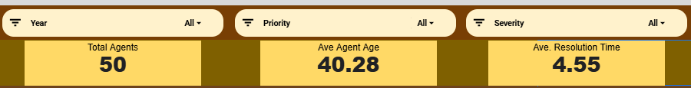
The average age is calculated using Average Formula
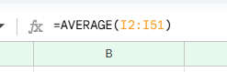

Q12. Is there a correlation between the severity of issues and the resolution time?
There is no significant correlation between severity and resolution time (Correlation ≈ -0.04). The chart also shows resolution time does not follow severity level consistently.
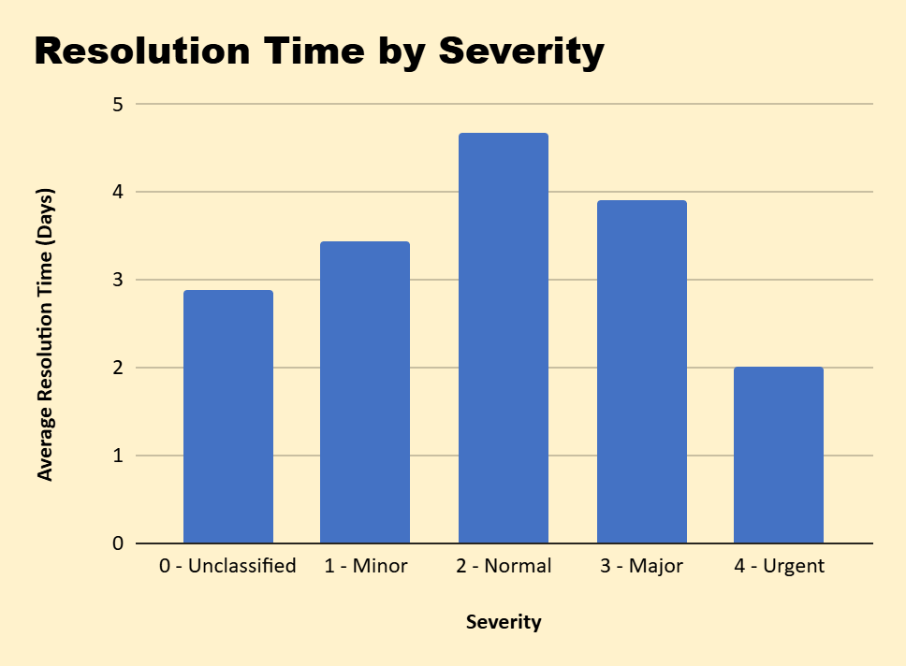
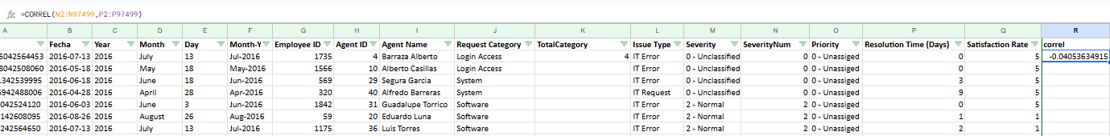

Q13. How many categorical columns are there in the data?
Categorical columns in Tickets Sheet = Request Category, Issue Type, Severity, Year, Month, Agent Name
Categorical columns in IT Agents sheet = Full Name, Email, EmailDomain
Total categorical columns : 10

Section 2: Subjective Questions -

Q1. If there is an investment, should it be used to hire more IT agents, improve training programs, or upgrade ticket management software?

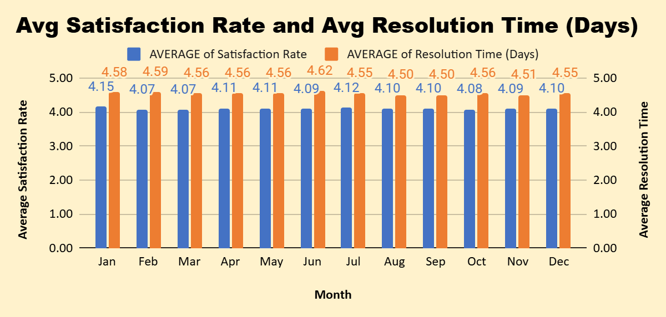

- To HIre Agents -

INSIGHTS :
From the dataset, we can understand that there are about 50 IT agents currently working to solve the tickets.
From the above chart, it's been observed that :-
- The tickets which have been resolved within a few hours or within a day, have a higher satisfaction rate.
- The tickets for which a longer resolution time is taken, have a very low satisfaction rate.
Recommendations :-
- By hiring more IT agents, workload on an individual agent can be reduced, thereby increasing productivity.
- Faster resolution leads to an increase in satisfaction rate.
- With more IT agents, tickets can be assigned and resolved faster, thereby reducing the waiting time of the tickets.
- During peak ticket volumes, it can also minimize delays and provide support efficiently.

B. About Improving Training Programs -

INSIGHTS :
We can filter out the agents based on the performance. It can be observed that here are employees with higher resolution time and also lower satisfaction rate, training can be provided to such employees to increase their productivity.

RESOLUTION :
- Need to identify in which category (Login Access, System, Software..etc) of tickets, the agent is struggling to resolve the query.
- We can also identify patterns where the resolution time of tickets is higher and provide necessary training on the same.
- Help the agent with FAQs, Guidelines or troubleshooting steps.
- We can also pair high-performing agents with those needing improvement.
- Assign senior agents to guide newer or struggling agents.
- Measure resolution time before and after training.

C. Upgrade Ticket Management Software -
INSIGHTS :
As it can be observed from the below table that a lot of tickets are unassigned to any of the agents. The tickets with the urgent severity are still unassigned which directly affects our satisfaction rates, it may also result in violation of service level agreement (SLA).

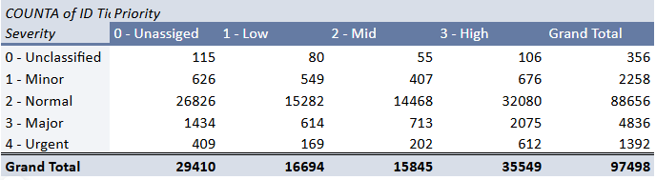
Unaddressed issues may escalate over time and may require more time and resources to get fixed. It can also lead to prolonged service interruptions and affect business operations.
RECOMMENDATIONS:
- Tickets need to be assigned immediately based on their Severity type.
- Use ticketing tools to assign high-severity tickets automatically to available agents.
- Always ensure that high-severity tickets are addressed first.
- Set up alerts about the unassigned ticket to any senior managers.
- Allocate senior agents to work on high severity issues.

Q2. Which agents need additional training based on their performance metrics?
INSIGHTS :

Targeted training should be given first to agents with high average resolution time (>5 days) and lower satisfaction (<4.0).
Examples from the table : Alfonso Barraza (AvgRes = 4.9 days), A. Trejo (=5.3), Lorena (=5.5), Elena Velez (=5.38) and others who show both higher resolution and lower satisfaction. Focus training on troubleshooting for common categories (System/Login) and customer-handling skills.
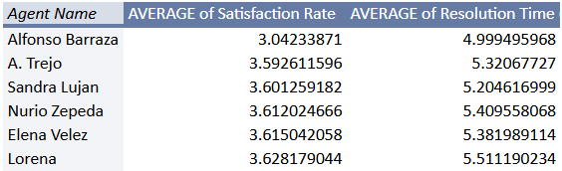

From the above table we can do these things -

RECOMMENDATIONS :

- Identify the areas in which the agent is underperforming, such as communication issues or lack of technical knowledge/skills.
- Check if the agent is using proper troubleshooting steps to resolve the query.
- Train the agent with the software and troubleshooting methods.
- Teach techniques to prioritize tasks and avoid delays
- Ensuring that they are not overwhelmed by too many complex tickets.

Q3. Do certain categories of requests have longer resolution times?

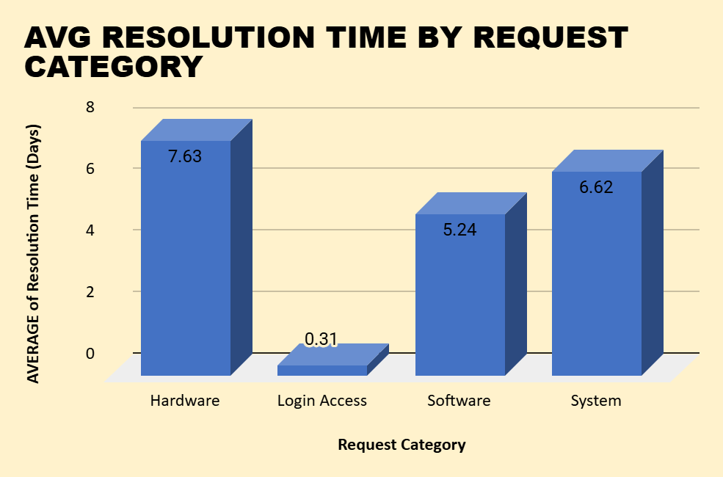

In the above chart we can see that Hardware and System category have the longer resolution time as compared to other two categories.

INSIGHTS :

- From the above chart, it can be observed that Issues Type –Hardware and System have longer resolution times compared to the other two, which indicates that specific challenges may be affecting the resolution process.
- Delays in assignment of tickets
- Complexity in identifying the root cause of the issue and providing solutions.
- Lack of technical expertise for resolving the issue.
- Delays in replacing faulty hardware parts.
- Insufficient software knowledge

RECOMMENDATIONS :

- Train agents to perform basic hardware fixes.
- Develop a documented base of common software issues and their solutions.
- Implement specialized teams to work on such issues with high accuracy.
- Regularly review the resolution time provided and feedback from employees.
- Schedule regular checks and updates to prevent any hardware failures
- Continuously monitor improvements in resolution times after making required changes.

Q4. How effective are the current software tools in managing IT tickets?

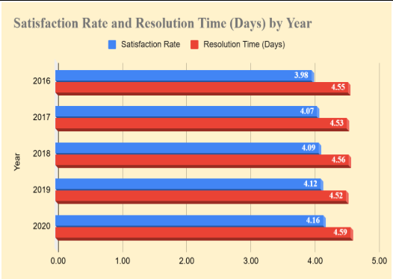

INSIGHTS :
- From the above pivot table, we can notice that the tickets with Urgent priority are left unassigned and also tickets are not being assigned based on the severity level and by considering the priority.
- The tickets were not assigned based on their severity level.
- SLA was breached due to delaying of assignment of tickets Leading to lower satisfaction rates and higher resolution time.
- Employees had to face a lot of waiting time.
- High volumes of tickets were left unassigned, increasing delays and workloads.

RECOMMENDATIONS :
After implementing the new tools,

- All tickets are tracked and managed effectively avoiding delays and ensuring no tickets are left unassigned.
- Alerting the agents about the High-severity tickets to be addressed quickly.
- Speed up ticket resolution times by providing ready access to solution for common issues.
- Helps in maintaining SLA compliance.
- Can handle increasing ticket volumes by hiring more agents and providing necessary training.
- Timely resolutions will enhance satisfaction ratings.

Q5. How has the performance of the IT support team changed over time (e.g.,monthly or quarterly)?
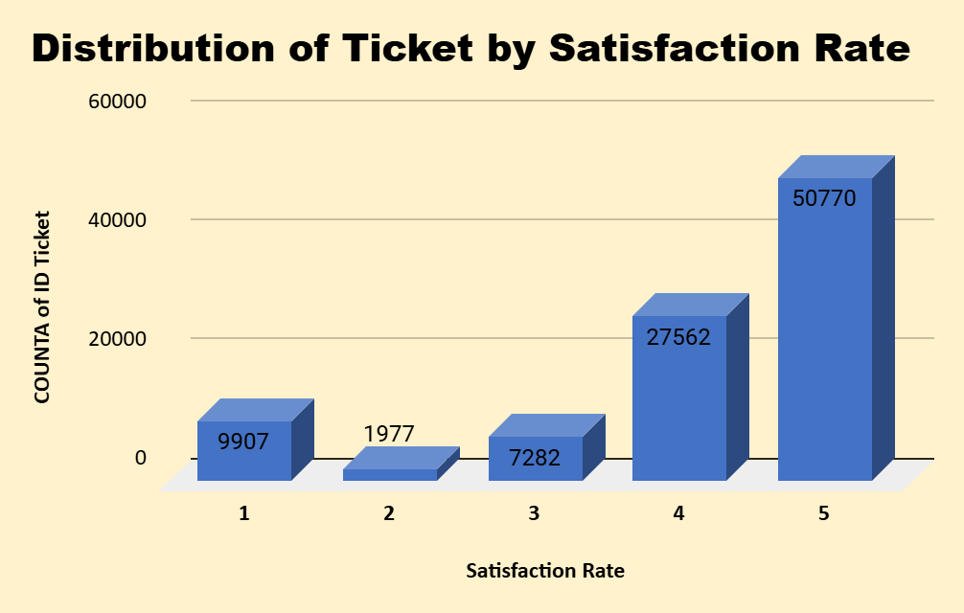
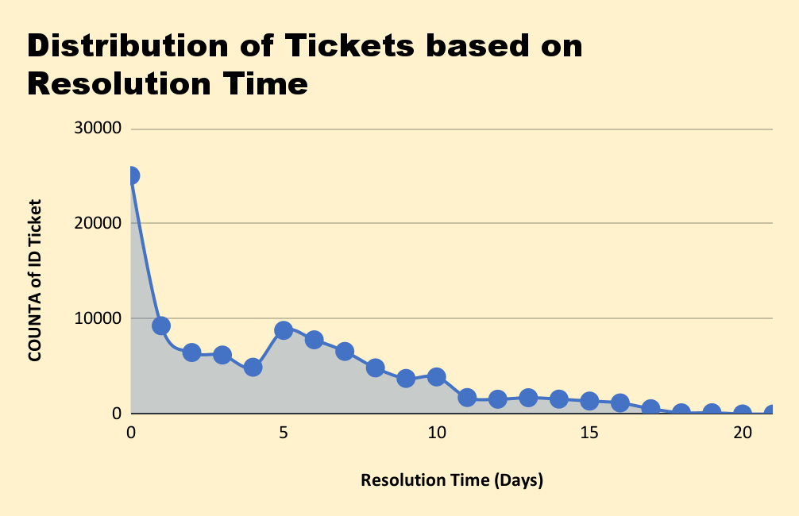

INSIGHTS :

- It is clear from the above chart that more tickets are resolved in the months of August, October and December.
- January being the month with a low volume of tickets being resolved.
- There might be fewer unresolved or overdue tickets in the month of Jan.
- Higher delays and dissatisfactions.
- Indicates insufficient resources and inadequate training.

RECOMMENDATIONS :

- Invest in advanced tools and automatic assignment of tickets to available agents, maintaining SLA compliance.
- Hire more agents to handle a large volume of tickets.
- Monitor and review the KPIs monthly or quarterly.
- Conduct regular training and upskilling sessions.
- Lower escalation rates as tickets have been assigned on time.
- Identifying top and under-performing agents.
- Rising satisfaction scores and better issue handling.

Q6. If we invest more on tech (Hardware, software, etc), do you think it will improve the ticket resolution times and employee satisfaction?

Request Category | AVERAGE of Resolution Time (Days) | AVERAGE of Satisfaction Rate
Hardware | 7.63 | 4.10
Login Access | 0.31 | 4.09
Software | 5.24 | 4.11
System | 6.62 | 4.10
Grand Total | 4.55 | 4.10

INSIGHTS :

- Slow working systems or outdated equipment can lead to longer resolution times.
- Lagging software issues can also cause the high waiting time leading to dissatisfaction rates.
- Miscommunication may happen between the agents and employees.

RECOMMENDATIONS :

- Upgraded hardware like faster computers, servers and networks can speed up ticket resolution by reducing downtime and lag for IT agents.
- Faster systems can resolve tickets more quickly, improving efficiency.
- Tools like chatbots and automated ticket routing reduce manual tasks, enabling agents to focus on higher-priority issues.
- Makes work smoother and less stressful, leading to higher satisfaction.
- If agents do not experience slow system issues or crashes, their productivity increases.
- Investing in multiple unintegrated systems can lead to fragmented workflows for IT teams, which could result in slower resolution times and confusion.
- Employees can connect with IT agents on Microsoft Teams, bridging the communication gap between them

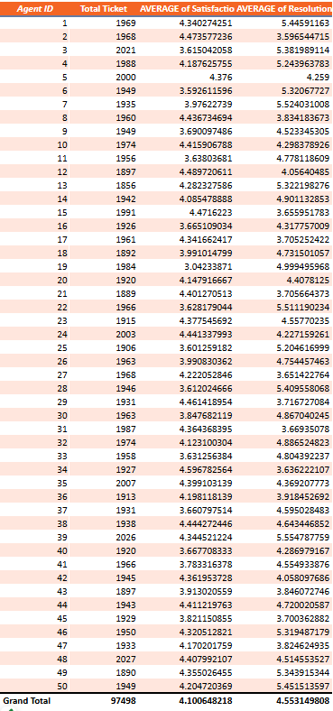
Q7. What are the key performance metrics for IT agents, and how can they be improved, do we need to fire any agents?
There are two major key performance metrics for IT agents are
- Average Resolution Time ( Days )
- Average Satisfaction Rate
- Number of Tickets Handled

INSIGHTS :

- Found few agents with lower satisfaction rates and also higher resolution times.
- Found few agents with high ticket count with higher resolution times.
- Found a few agents with low ticket count with low satisfaction rates.
- Found top-performing agents with lesser resolution time and higher satisfaction rates.

RECOMMENDATIONS :

- To the least performing agents, proper training needs to be given.
- No need to fire any agents as they can be trained on specific areas in which they need to be upskilled.
- Provide additional training and support tools to agents.
- Ensure agents have the complete knowledge or skills required to handle the tickets.
- Implement a system to follow up with any dissatisfied employees.
- Provide agents with better task management and time-tracking tools to stay on track.
- Add temporary resources during periods of high ticket volume.
- Set clear, measurable goals with timelines.

Q8. How do employee demographics (e.g., department, seniority) impact satisfaction and ticket outcomes?

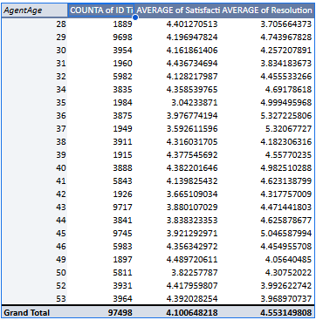

INSIGHTS :

- From the dataset, it’s been observed that the average age of the employees is 40.14.
- Most of the employees are aged above 35, may hold a good number of experience in the same field.
- Their experience can lead to better resolution of complex issues.
- They may be more patient and thorough in addressing issues, often leading to higher customer satisfaction.
- Agents with high experience may have better skills and problem-solving abilities which can result in quicker resolutions for complex issues.

RECOMMENDATION :

- Agents with low experience may need regular training programs to improve their skills and capabilities.
- Agents with longer tenure may feel more satisfied if they have been promoted or recognized for their contributions.
- Newly hired agents might feel more satisfied if they receive proper onboarding, training and mentorship.

Q9. Identify the trends for IT support operations based on ticket volumes and satisfaction, and mention the peak and stable times?

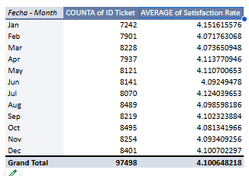

INSIGHTS :

- It can be observed that the months August, October and December have a higher number of tickets count compared to other months.
- January is the month with the lowest count of tickets but with highest satisfaction rates.
- In the months May, June and July there is not much increase in the count of tickets, depicting some sort of stability.
- Lowest satisfaction rate is being recorded in the month of Feb and Mar.
- Tickets volumes are high and satisfaction is dropped due to delayed responses or unassigned tickets.

RECOMMENDATIONS :

- During peak time, more resources need to be allocated to reduce waiting time for tickets and provide quicker resolution.
- When the ticket volume is low, agents can be given proper training to upskill their knowledge about hardware or software to handle the tickets more efficiently.
- Use severity and impact levels to streamline the workflows.
- Use stable periods to perform system updates or hardware maintenance.
- Continuous monitoring of ticket trends and satisfaction metrics ensures smoother operations and improved employee satisfaction.

Q10. What metrics should be included in the final dashboard to provide a comprehensive view of call center performance and guide investment decisions?

The metrics that should be included in the final dashboard to provide a comprehensive view of call center performance and guide investment decisions are as follows :-

- The major numerical metrics such as :-
  - Total Tickets
  - Total Agents
  - Average Agent Age
  - Average Resolution Time
  - Average Satisfaction Rate
  - Average Ticket Volume

- Multiple (6) Slicers to make the dashboard interactive and make the most out of its data! Slicers added are :-
  - Satisfaction Rate
  - Year
  - Priority
  - Severity
  - Issue Type
  - Request Category

- 9 different charts which together form the dashboard along with the slicers and KPIs. The details of all these charts are as follows :-
  - Pie Chart - Tickets by Request Category.
  - Column Chart - Volume of Ticket over Time.
  - Line Chart - Average Satisfaction Rate Over Time.
  - Column Chart - Average Resolution Time by Request Category.
  - Column Chart - Age Group by Satisfaction Rate.
  - Bar Chart - Tickets by Severity Rate.
  - Bar Chart - Tickets by Priority.
  - Column Chart - Distribution of Tickets by Satisfaction Rate.
  - Line Chart - Distribution of Tickets based on Resolution Time.

